SVZ CONTINUES ITS DEVELOPMENT

Sylvain PAILLOTIN becomes Partner

in charge of Special Situations and Restructuring

Paris, 25 April 2017

The partners of Sekri Valentin Zerrouk law firm (SVZ) are pleased to announce the promotion of Sylvain Paillotin as Partner in charge of special situations and restructuring.

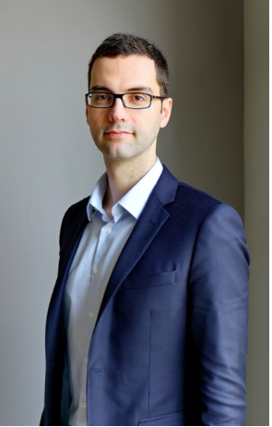 | Sylvain Paillotin assists executives and groups facing cash shortfalls. A specialist in insolvency law, he deploys the legal tools necessary to overcome these situations. He also advises creditors or shareholders of companies in special situations, as well as buyers acquiring assets in court. He also frequently represents bankruptcy trustees and court-appointed liquidators.  His experience in restructuring complements the firm’s expertise in the area of Distressed M&A, and in particular the approach to conflict resolution for major industrial disputes led by Jean-Marie Valentin.  Sylvain Paillotin is a member of the IFPPC (Institut Francais des Praticiens de Procedures collectives - the French Institute of Bankruptcy Practitioners) and of the IBA.
Sylvain Paillotin, who earned a post-graduate diploma (DESS) in business law and taxation from Paris II Assas and a Diploma in Legal Studies from Oxford University, started out at Dentons (formerly Salans) in 2006 in litigation and mergers & acquisitions before joining Gide in 2009 where he specialised in restructuring. He joined SVZ in 2013 to develop the special situations and restructuring practice. Sylvain is an active member of the International Bar Association and co-author of the book Financing Company Group Restructurings (Oxford University Press, 2015).

In recent years, Sylvain has worked on a number of leading restructuring cases for distressed companies, such as Orco Property Group (bond restructuring of more than €500 million as part of a safeguard procedure), Photowatt (450 employees, revenues of €160 million – receivership and takeover by EDF-ENR), Virgin Stores (1,145 employees, revenues of €305 million – preparation and filing for receivership), Continentale Nutrition (350 employees, revenues of €32 million, advising shareholders). He regularly works alongside Jean-Marie Valentin on trust structuring within the framework of major special situations (Petroplus, Kem One, Lyondelbasell, Sony, Kering/La Redoute, SNCM, etc.). He advises both distressed companies and their shareholders or institutional creditors (IDIA Participations, FedEx, etc.), and assists investors willing to acquire assets which are part of insolvency estates.

"We are delighted that Sylvain is becoming our tenth partner, thus creating total parity within our partnership. This appointment embodies the in-house values our firm seeks to promote, i.e. reward expertise, help our associates grow by offering them real opportunities, and for those who so wish, take part in quite a unique entrepreneurial project on the Paris market…" says Franck Sekri, founding partner.

"I am very pleased with my appointment and this new challenge which reflects the true and lasting synergy between Restructuring and the firm's other practices. In the last few months, the firm has considerably reinforced its offer in financing and real estate, and has developed new collaborative working tools, enabling us to provide a comprehensive panel of high value-added solutions, including for special situations. I plan to speed up the development of the Special Situations and Restructuring practice by relying on our human and technological resources," says Sylvain Paillotin.

About Sekri Valentin Zerrouk
Sekri Valentin Zerrouk is an independent and entrepreneurial firm comprising some forty lawyers. The firm advises multinationals, leading investment funds, mid-caps, SMEs and entrepreneurs within the framework of their business activities and acquisitions, sales or restructurings in France and abroad thanks to its international ecosystem of over 200 lawyers recognised among the best.
With over 180 M&As completed in the last ten years, Sekri Valentin Zerrouk is today one of the most renowned law firms in Mid-Market transactions.
Sekri Valentin Zerrouk is also a market-leading law firm in terms of innovation through the launch of MySVZ and LegalCluster, two significant client-relationship innovations.
The firm's ten partners are: Franck Sekri, Jean-Marie Valentin, Géraud de Franclieu, Emmanuelle Vicidomini and Sylvain Paillotin, (Mergers & Acquisitions, Private Equity, Financing, Restructuring), Yamina Zerrouk (Public Sector Business Law, Urban Planning and Real-Estate), Jérôme Assouline (Tax Law), Emilie Meridjen (Labour Law), Anne Dumas-L’Hoir (Trade Litigation) and Emeline Peltier (Real Estate).

